This is a list of screenshots of the “Monitor” application with brief descriptions.

To run the application, user must execute the “Monitor.exe” file.

After startup, Monitor establishes a network connection with the “Configuration Service” and receives all schemes and signals lists. After that it establishes a connection with the “Application Data Service” and receives the information about signals’ parameters and states permanently.

The main window of the application is shown below. It contains a toolbar, a main menu bar, a tab bar, a scheme displaying area and a status bar.

The toolbar contains “New tab” () button, zoom buttons (), schemes list combo box (), “Previous” and “Next” () buttons, and buttons to run “Snapshot”( ) and “Search” () windows.

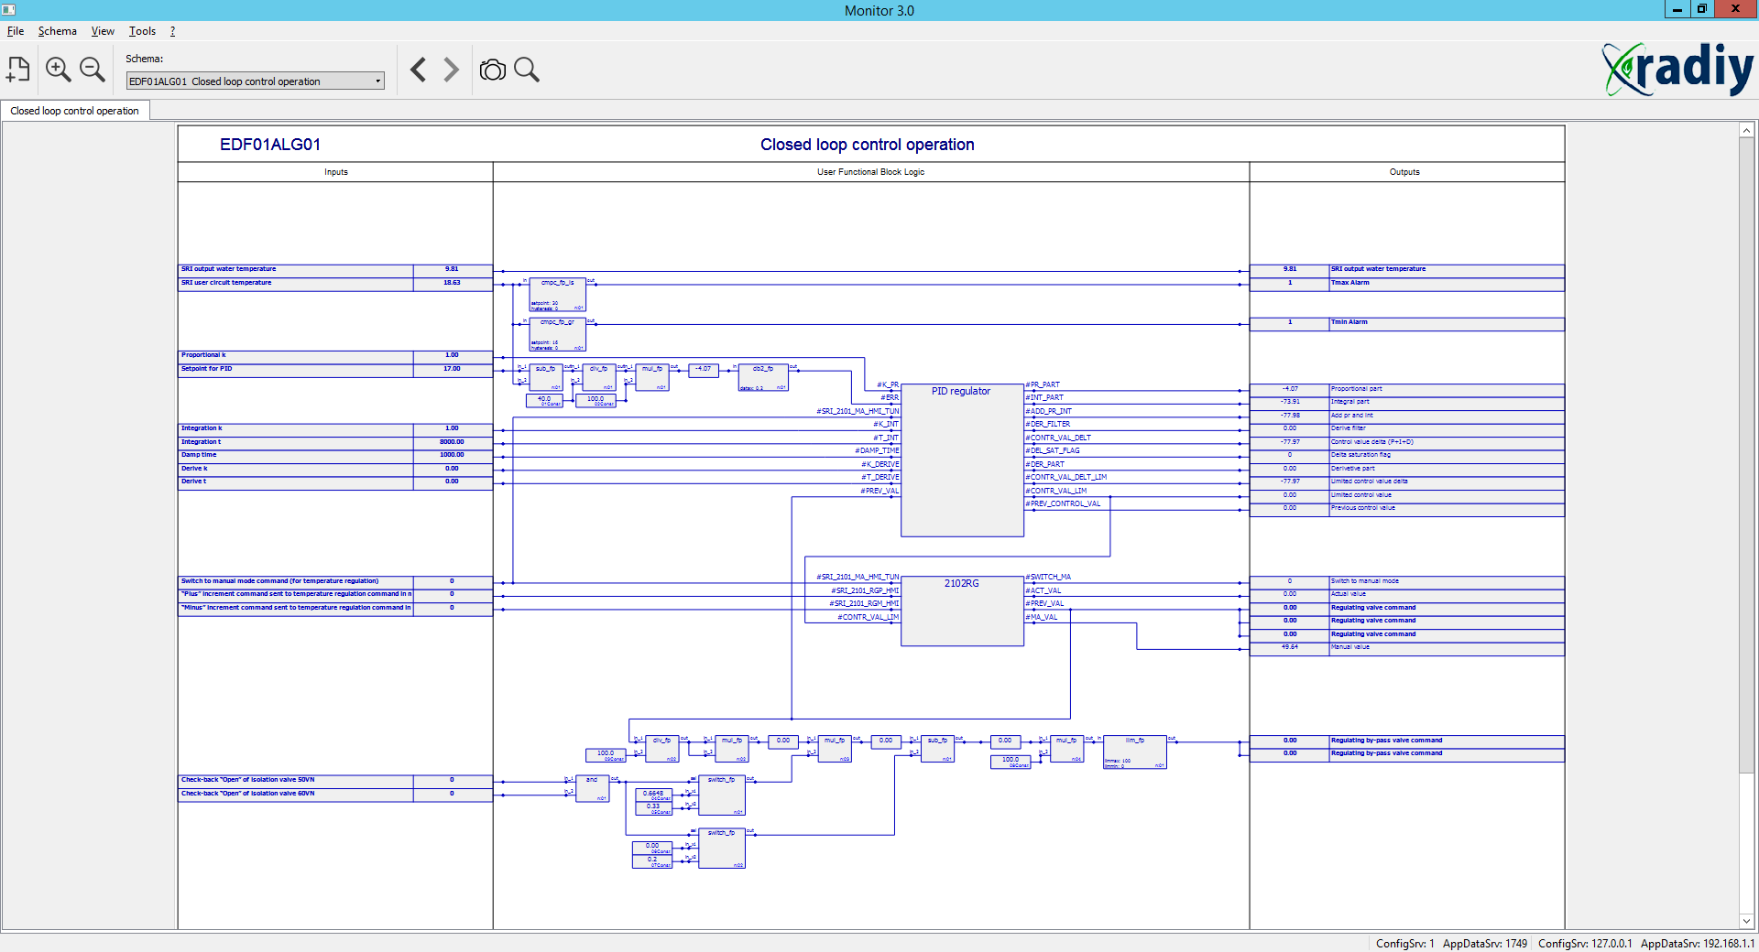

User can zoom the scheme view using buttons on the tool bar or using the mouse wheel.

Here is a screenshot with a zoomed scheme. Analog signals values are displayed as numbers, discrete signals are displayed as “0” or “1”.

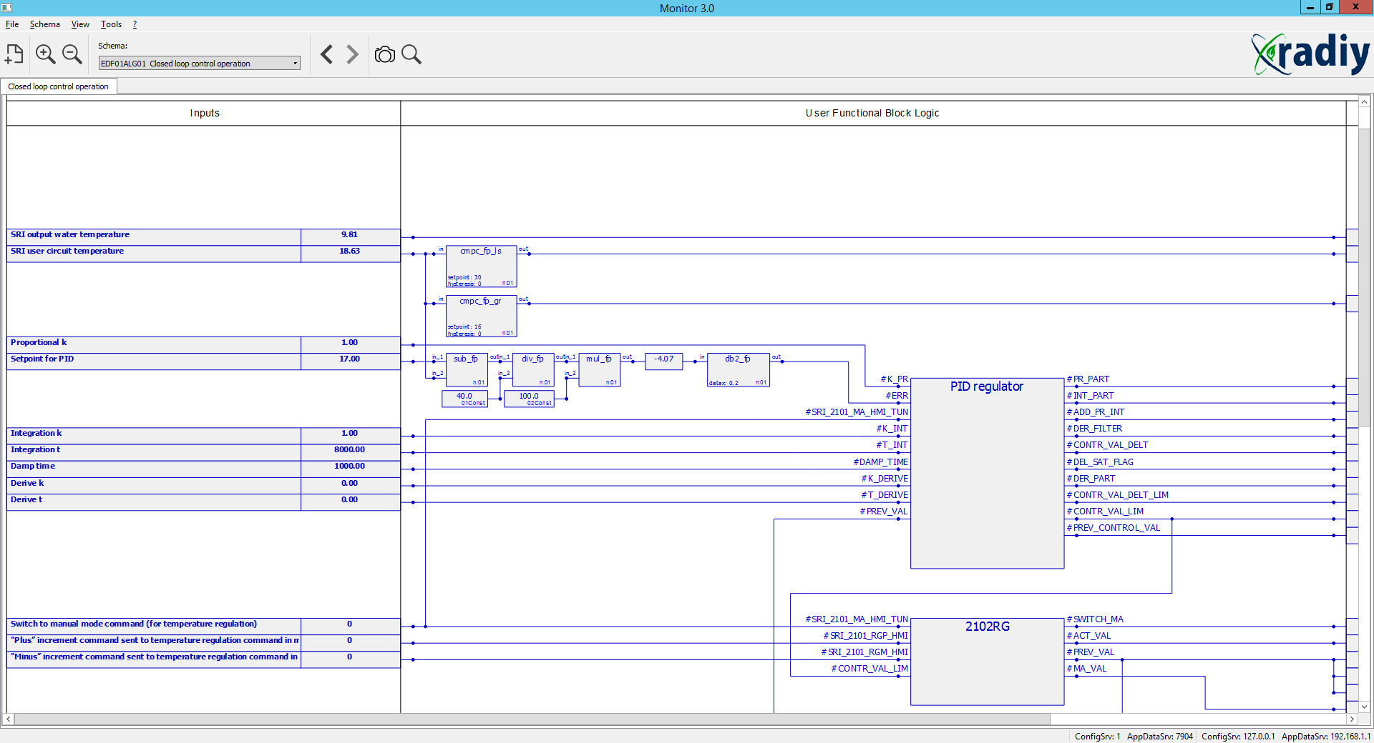

If no connection with “Application Data Service” is established, signals parameters (names and identifiers) and values are displayed as (“?”).

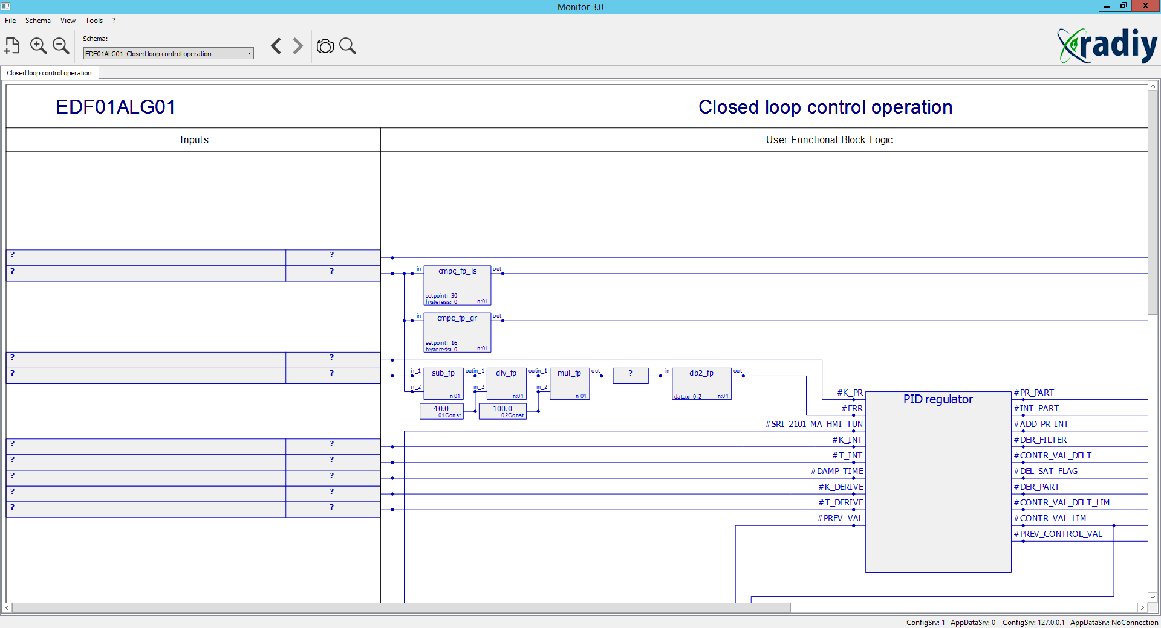

If a connection with “Application Data Service” is established, but no valid signals values are received from the hardware, these values are also displayed as “?”.

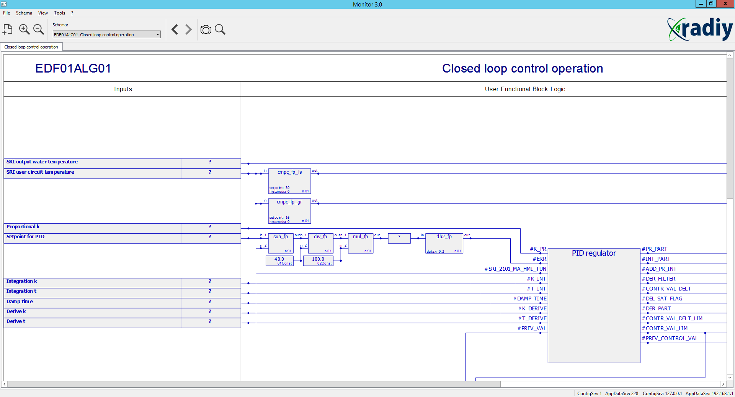

A few schemes can be displayed by the program at the same time. To open a new scheme, user can click the first button on the toolbar or use the “Schemes” menu. Then schemes can be switched using tabs shown below.

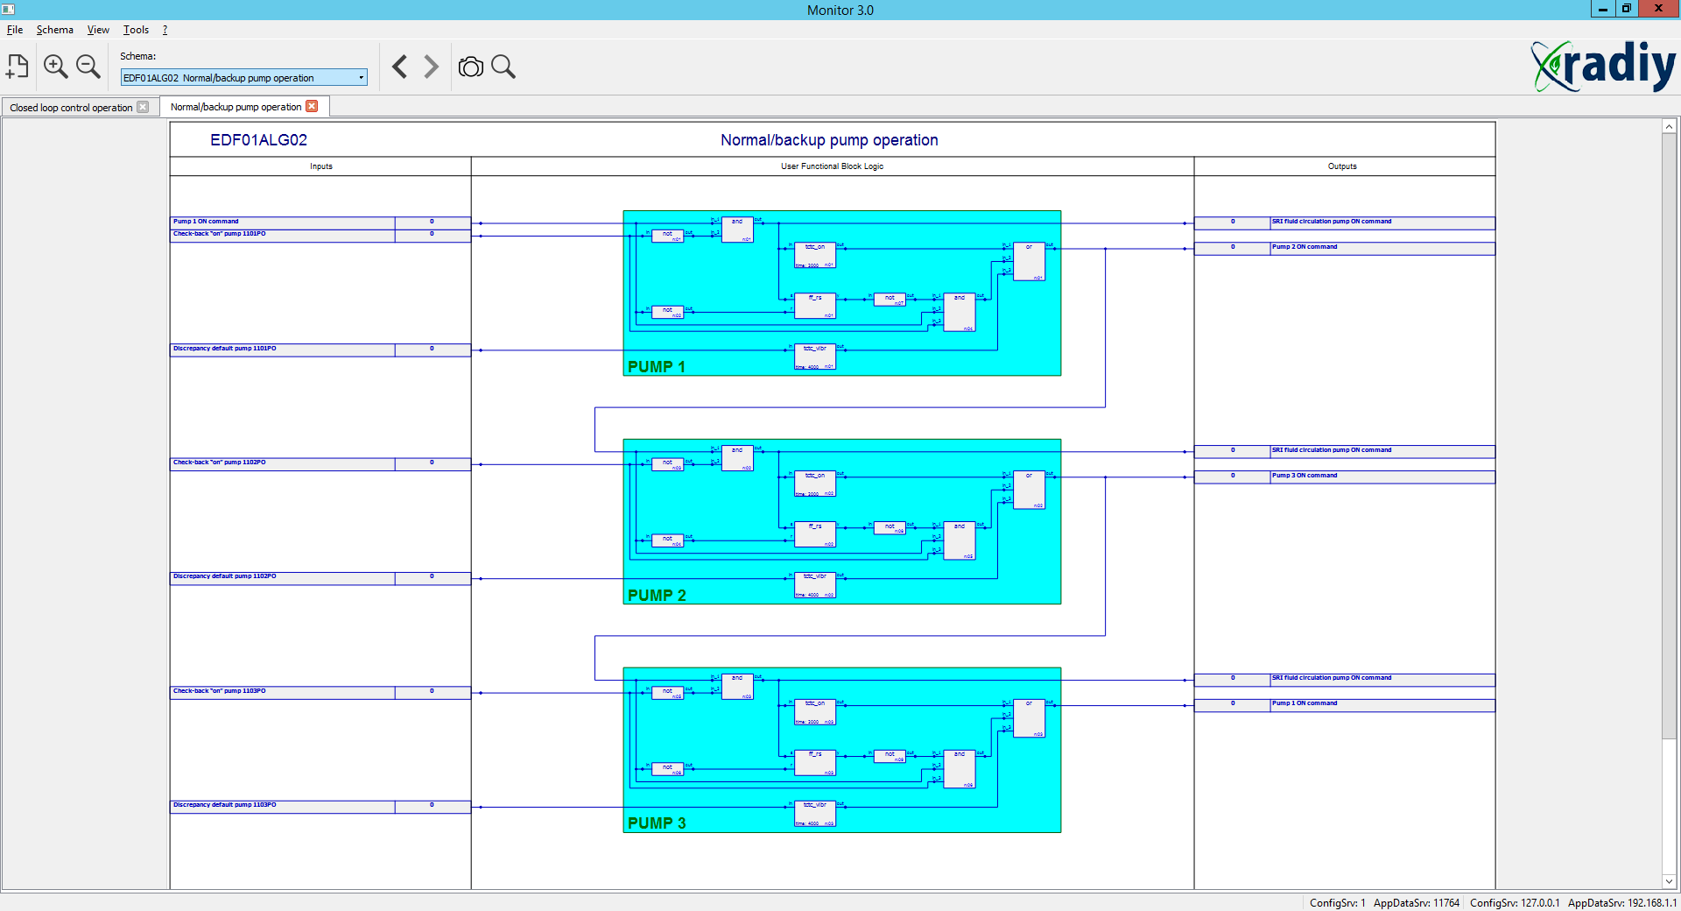

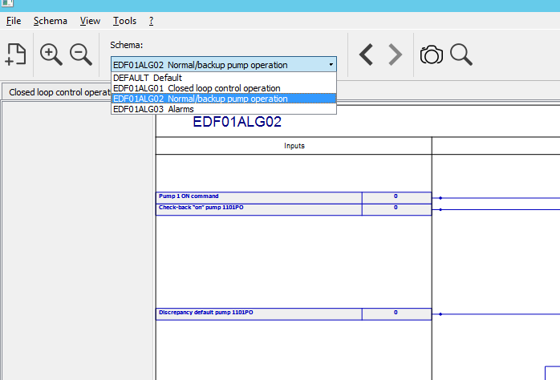

To view an extended signal information, click the right mouse button on a signal element on the scheme. A pop-up menu will be displayed. It contains an identifier and description of a signal.

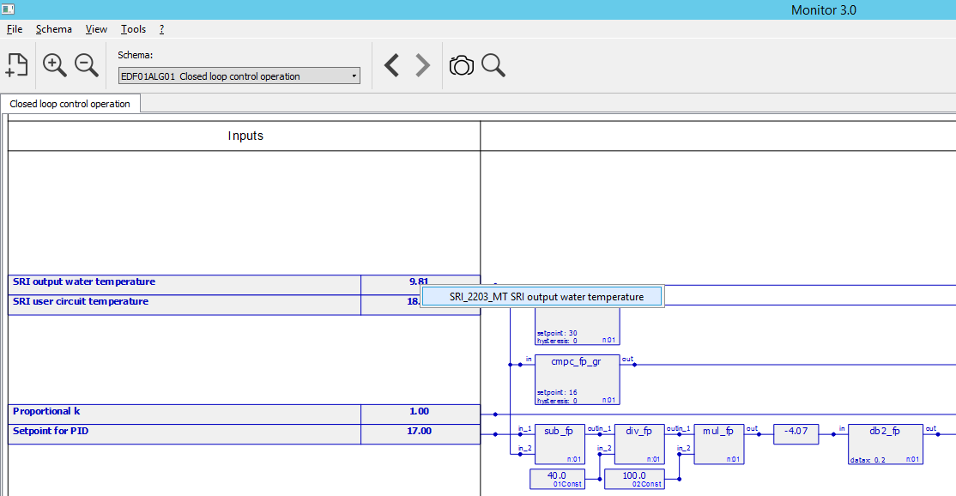

The signal information window is shown below. It contains general signal information and different tabs. The “State” tab shows signal’s current value, flags (“VAL” - validity, “OVRFLW” - overflow, “UNDRFLW” - underflow) and time when this signal was registered.

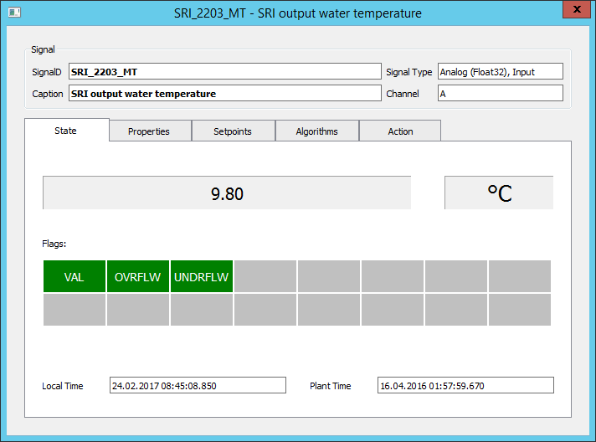

The value of a signal can be shown in different ways, with different decimal points number and in different calculation systems. User can choose the view using the pop-up menu. To run this popup menu, click the right mouse button on the value.

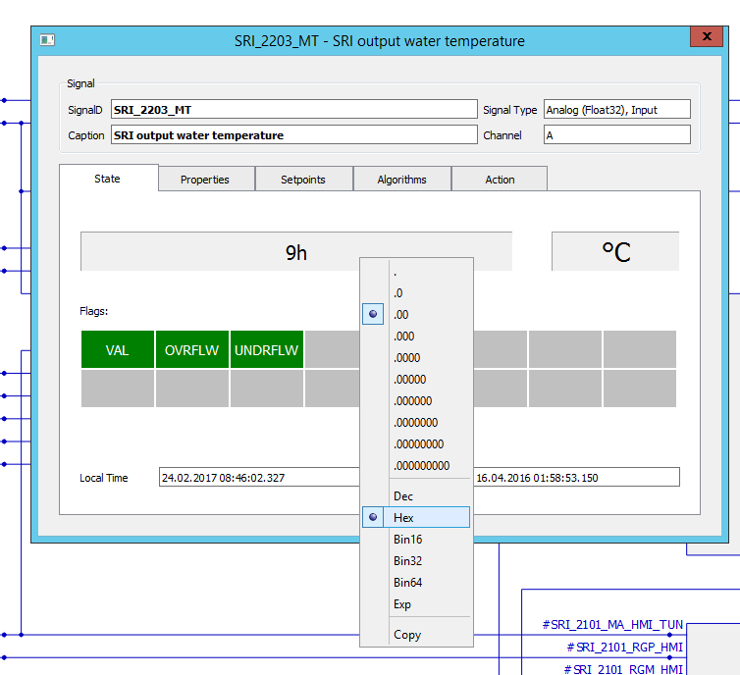

The “Properties” tab contains all signal’s properties.

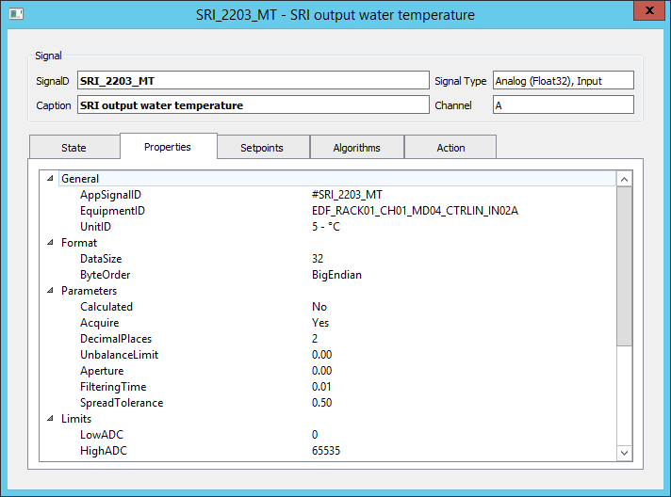

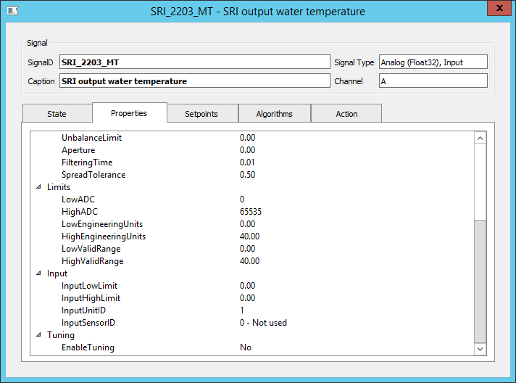

To find a signal by its identifier, call the “Signal Search” window by clicking “” button or choose it from “Tools” menu. Then enter a part of a signal identifier. Signals that match this part will be shown in the list.

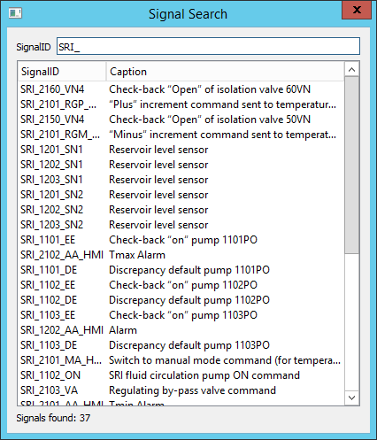

To view signal’s properties, user can click the right mouse button on the list and use the pop-up menu.

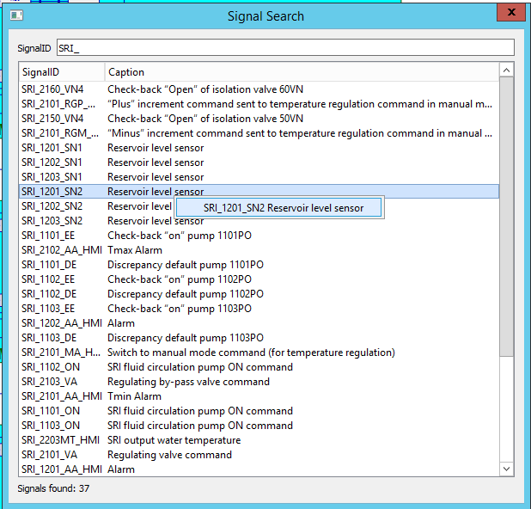

To view the list of all signals, run the “Signals Snapshot” window by clicking “” button or use the “Tools” menu.

A shapshot window conations different fields. “Signals Filter” has controls that allow user to select different sets of signals: “Signal Type”, “Schema”, “Mask” and “Preset” (this is under development). A mask contains “\*” and “?” symbols. To apply the mask, press “Apply” button. The combo box at the right of the “Mask” field selects a property that mask applies to (“AppSignalID”, “Caption” etc).

“Export” and “Print” buttons will allow exporting and printing the data. But now are under development.

“Columns” button allows user to choose columns that are displayed in a list.

When “Fixate” button is released, signal values are permanently updated. When it is pressed, values are not changed.

“Value” column displays signal’s value and flags. Non-valid value is displayed as “?”.

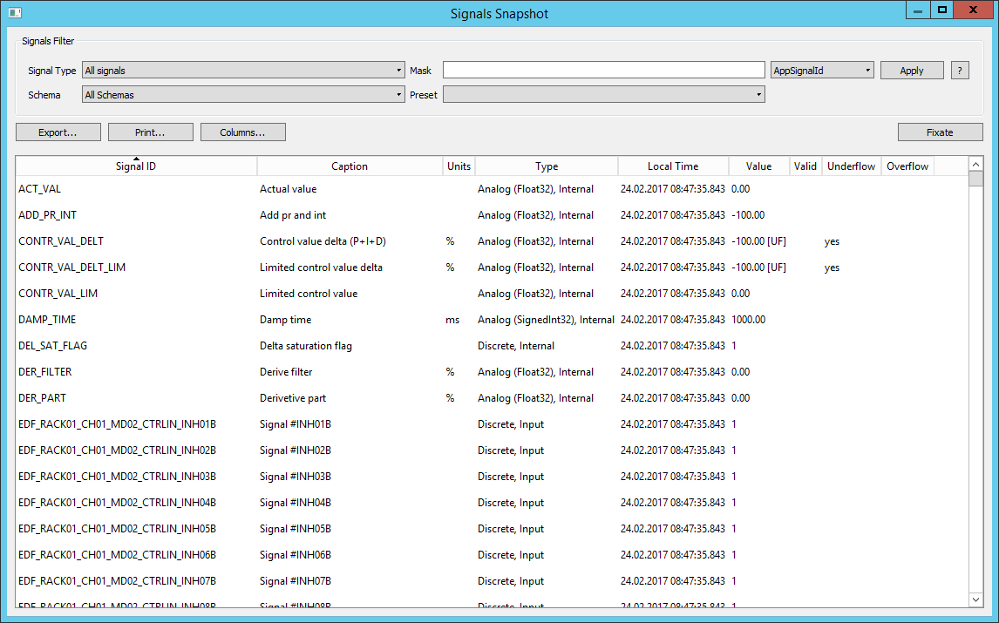

The “Choose Columns” dialog is shown below. To add and remove columns, use “>” (add), “>>” (add all), “<” (remove), “<<” (remove all) buttons. Also to add or remove, double-click the left mouse button on the list item. To change columns order - “Move Up” and “Move Down” buttons.

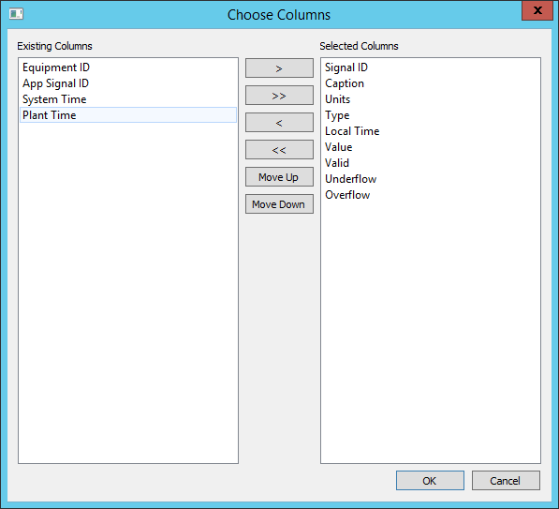

To use the “Monitor” application, project designer must add the “Monitor” preset to an Equipment tree in the RPCT Tool as shown below.

The “Monitor” preset has following significant properties:

“AppDataServiceID(1/2)” - Equipment ID of Application Data services it connects to;

“ArchiveServiceID(1/2)” - Equipment ID of Archiving services it connects to (now is not used);

“ConfigurationServiceID(1/2)” - Equipment ID of Configuration services it connects to (now is not used);

“EquipmentID” - Equipment ID of the Monitor preset itself. It must be entered in the “Settings” window of the “Monitor” application.

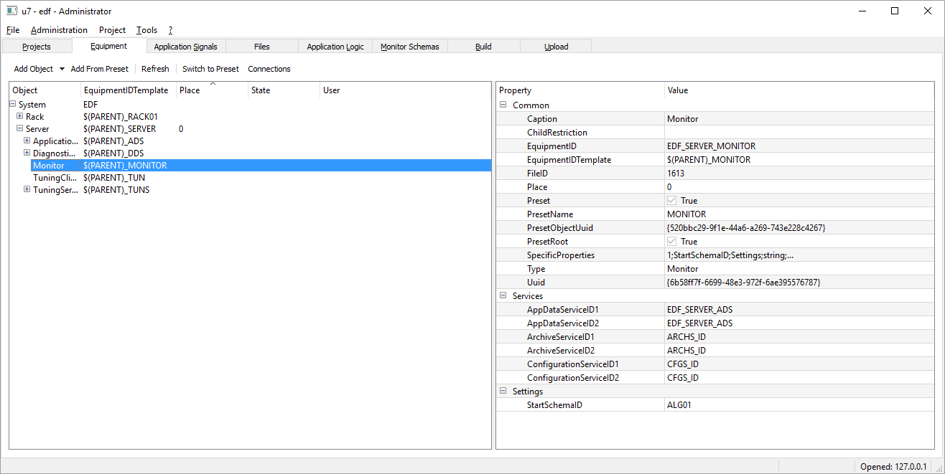

To edit the application settings, use “Settings” window from “Tools” menu.

The “Connection” tab contains an application ID from the “Equipment” tree in RPCT, IP addresses and ports of the Configuration Service.

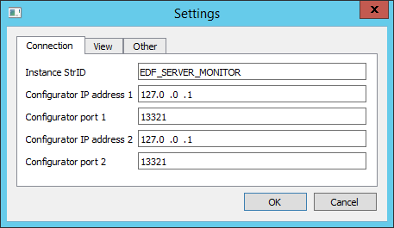

The “View” tab contains different view options: “Show Logo” and “Show Items Labels”.

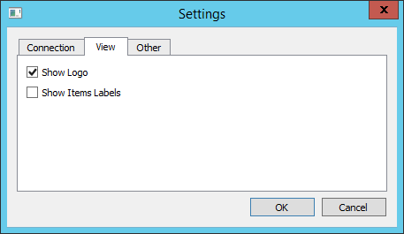

Note - the “Show Items Labels” option is used for debugging, it shows the debugging information on schemes.

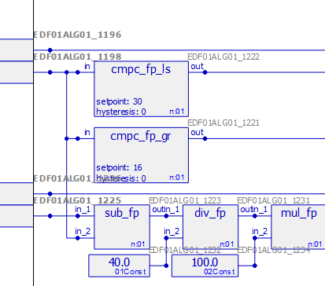

The “Other” tab contains a “Single Instance” option.

